
full stack web development lab
Ms. Fiza Asmat

hassan shahid
241790
bscs 5c

LAB 07

Lab Task:

Checking whether node and npm are installed:
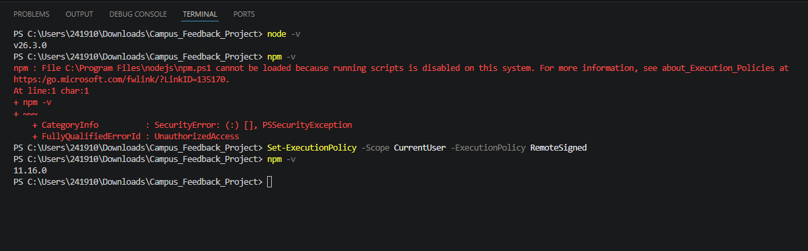
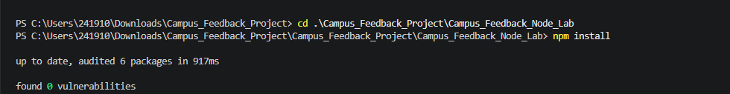

npm start to run the files:
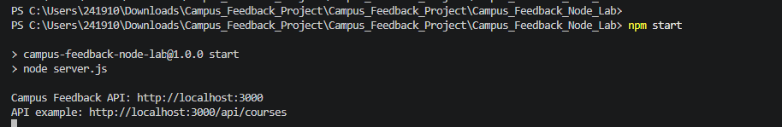

Running example 01 file:
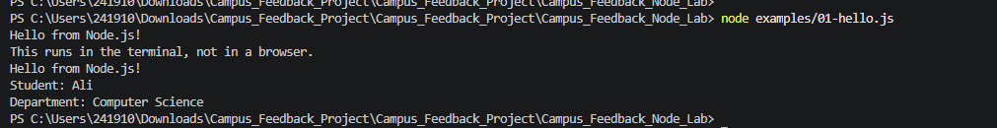

Commenting out first line in example 02 file:

Normal run:

Commented run:
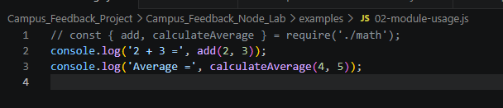
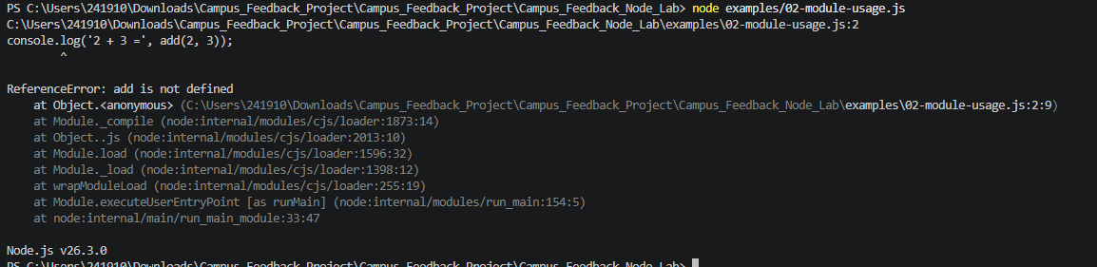
So we have a reference error because the “require” is missing.

Adding max function:
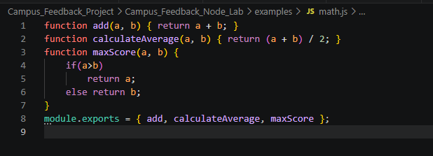
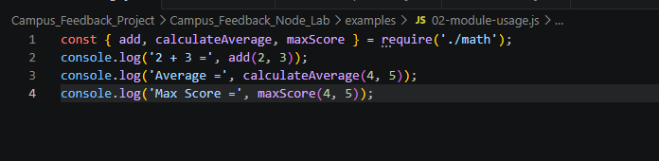
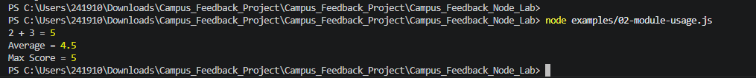

Running example 03 file:
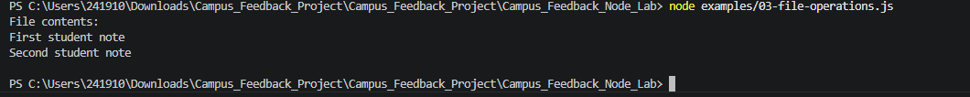

Making and running attendance.js:
attendance.js file:
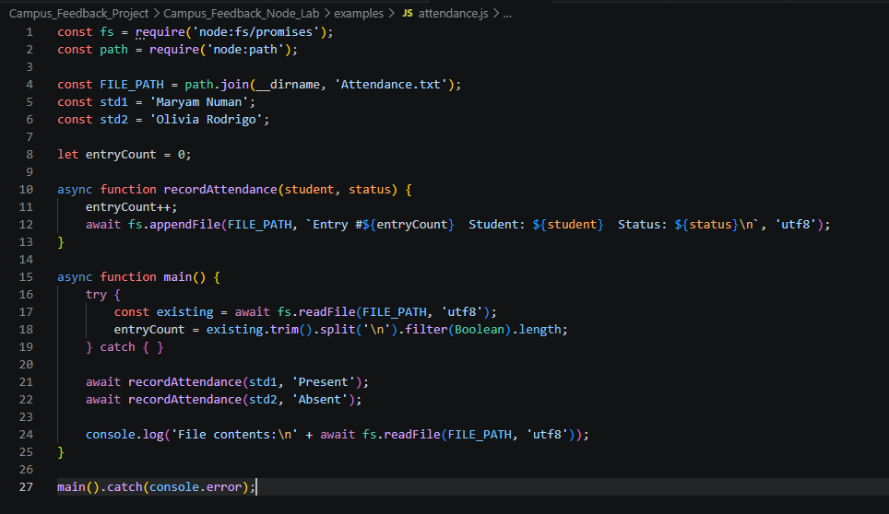

Terminal:
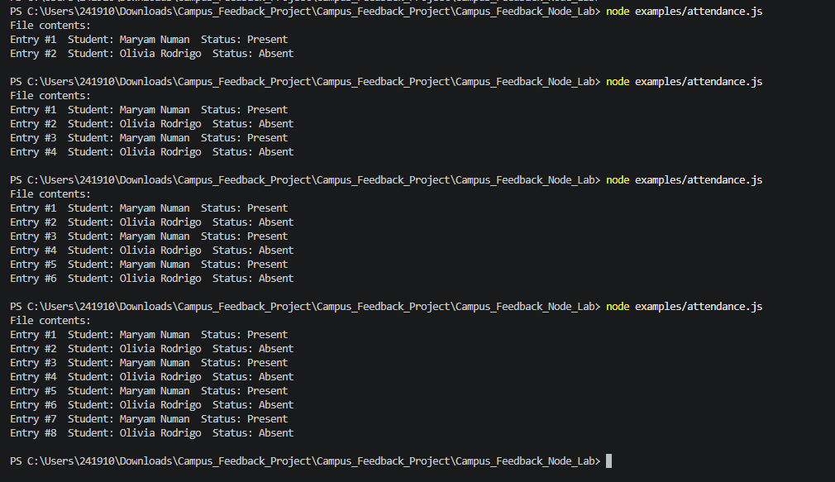

attendance.txt:
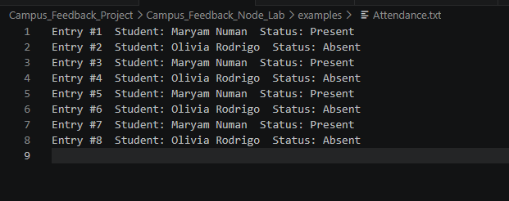

Running example 04 file:
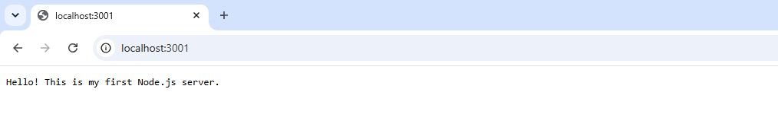

Home Task:

Case Study: Campus Lost & Found API

Task 1 — Design the Item, Data Shape and Reusable Modules (Modules, Separation of Concerns):
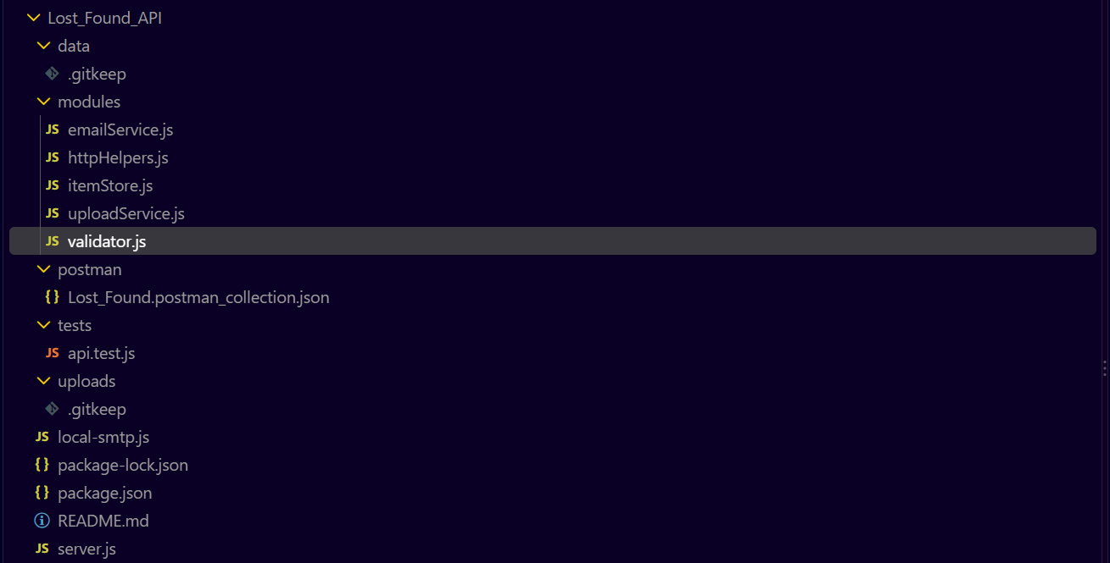
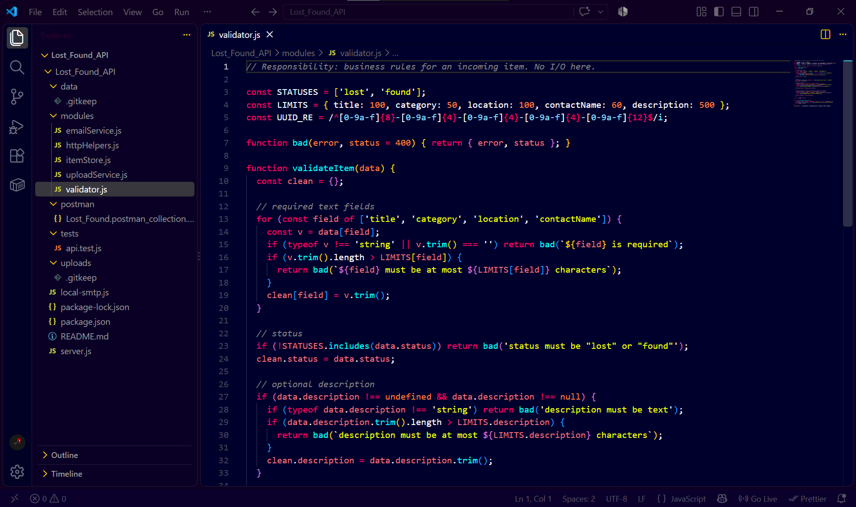

Task 2 — NDJSON File Persistence (fs, Async Files, Error Handling):
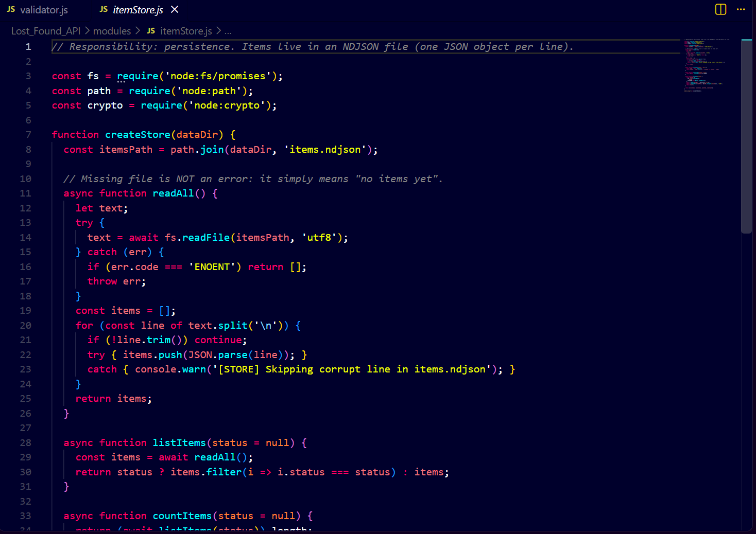
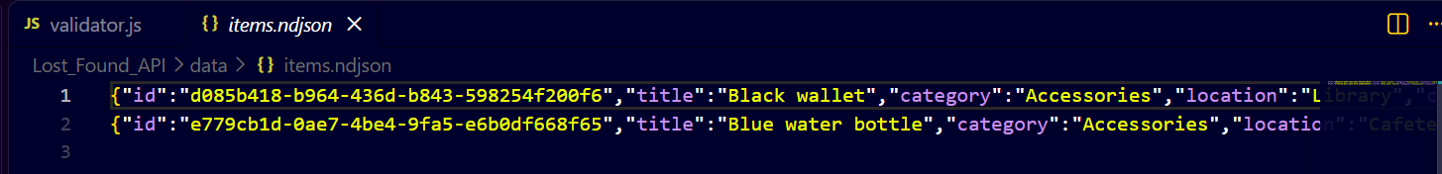
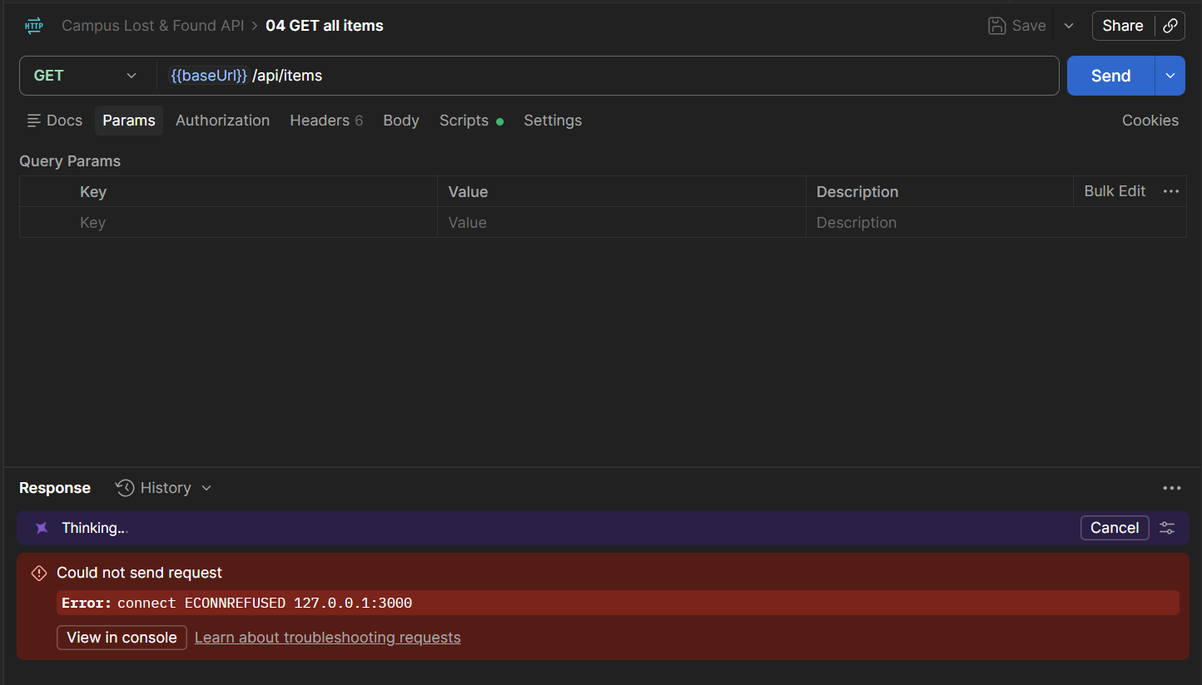

Task 3 — Endpoints, Validation and Status Codes (HTTP Routing, JSON):

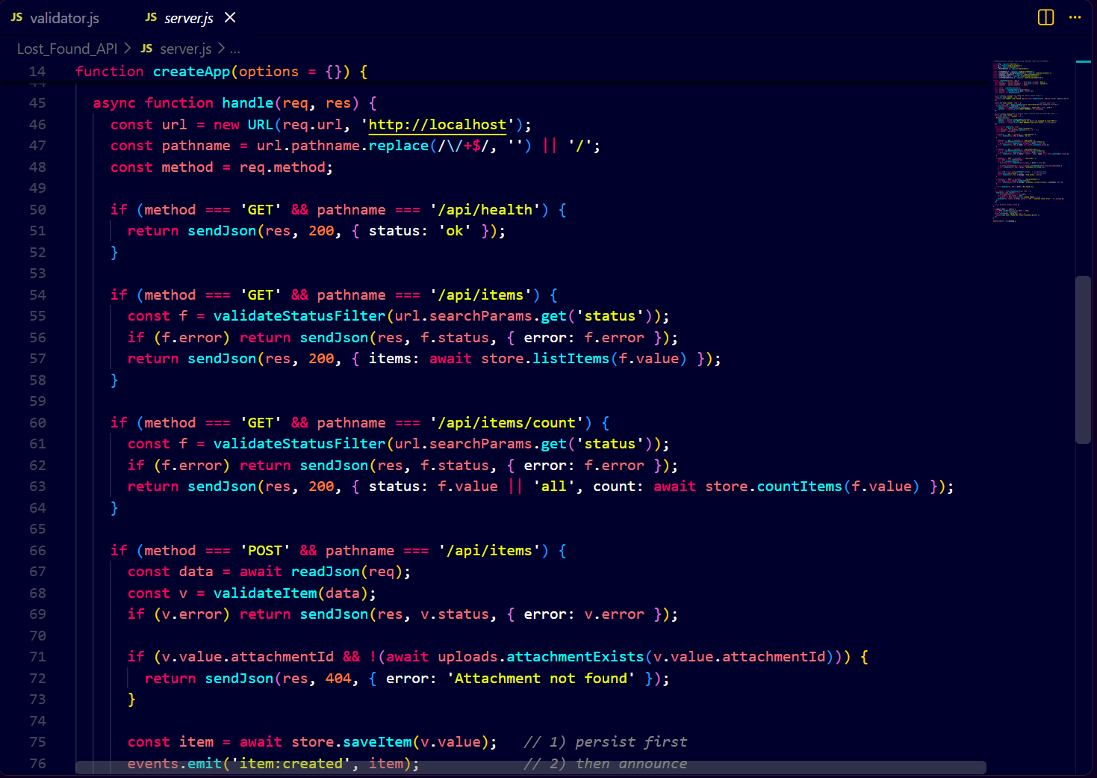
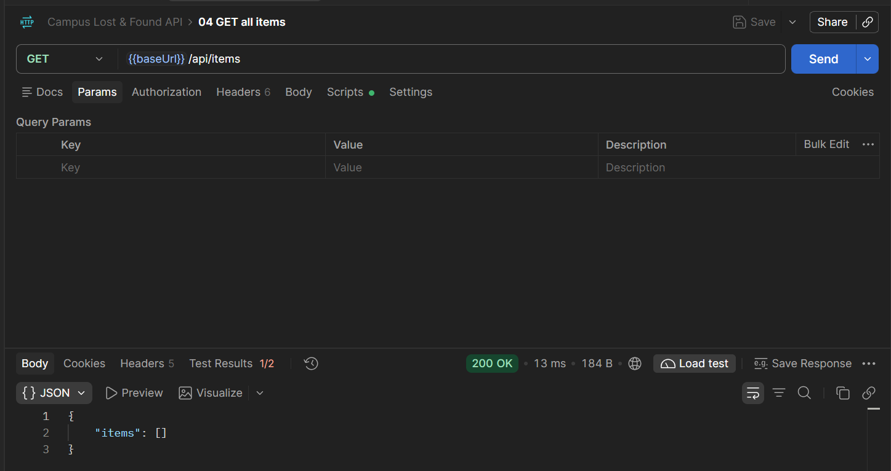
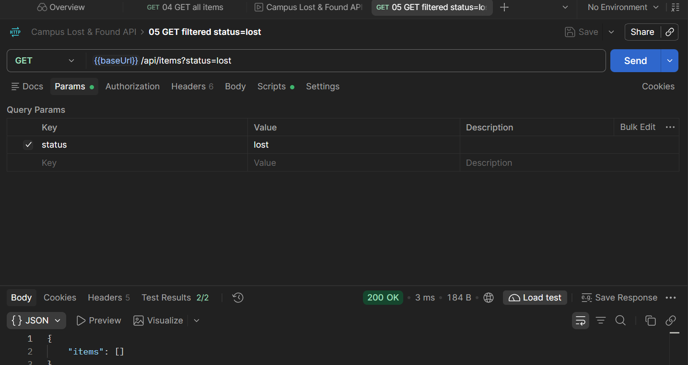
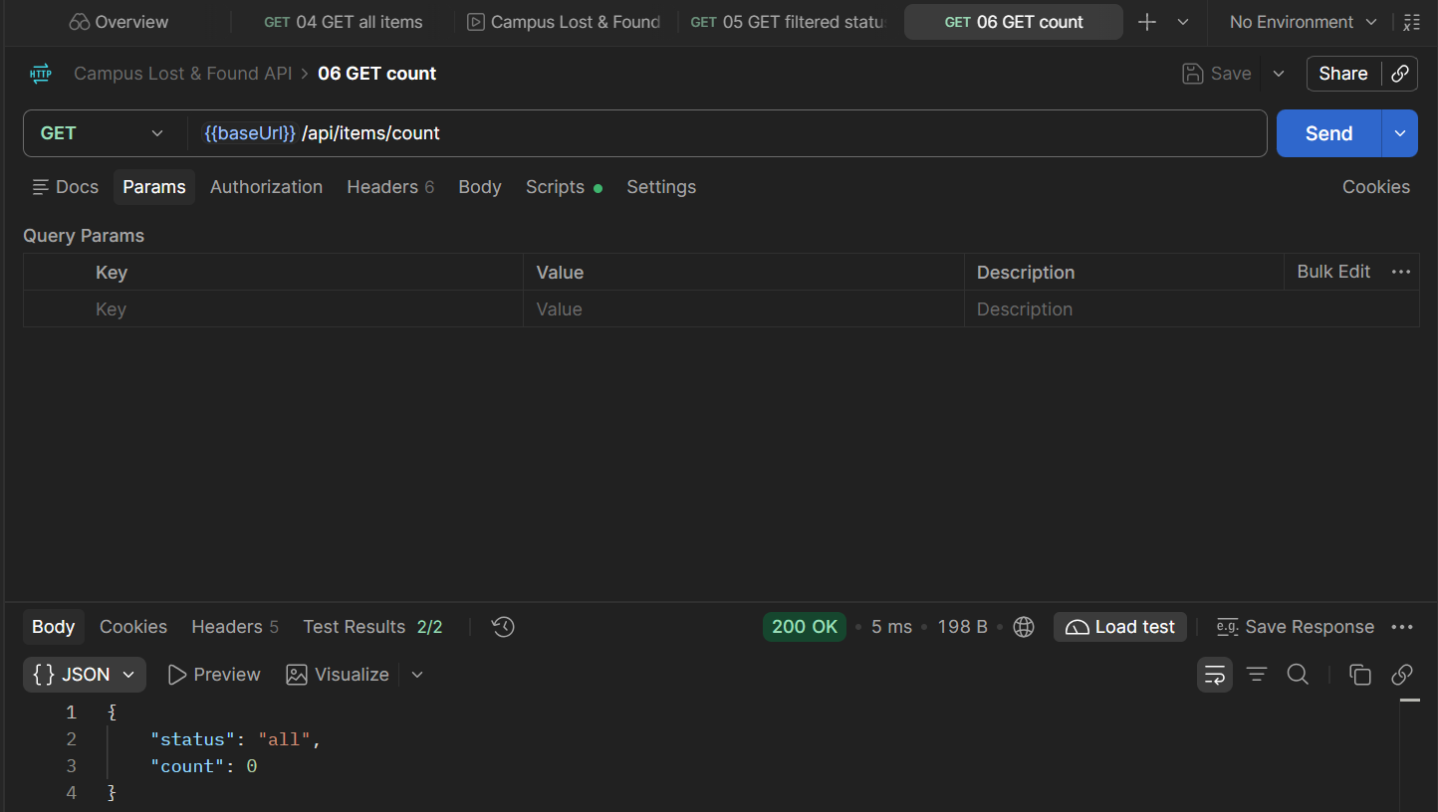
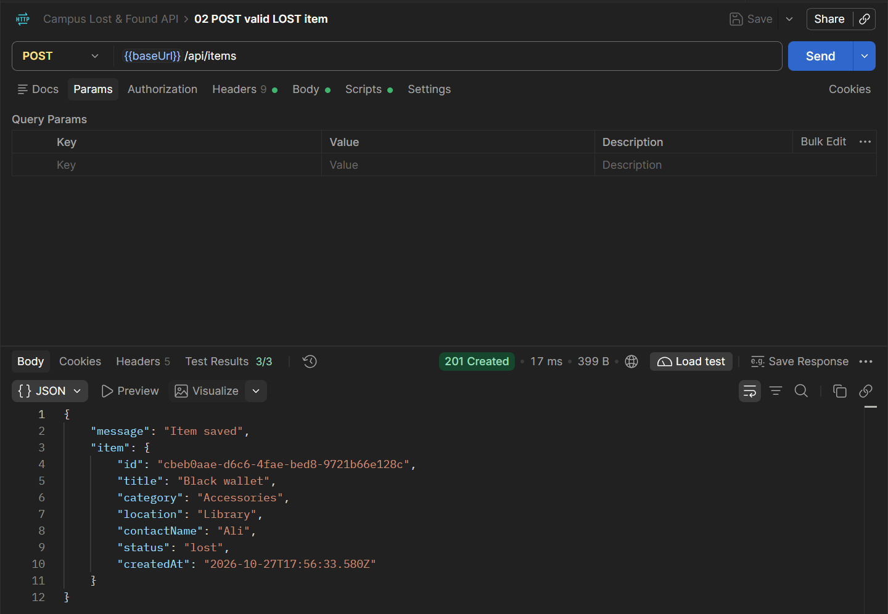
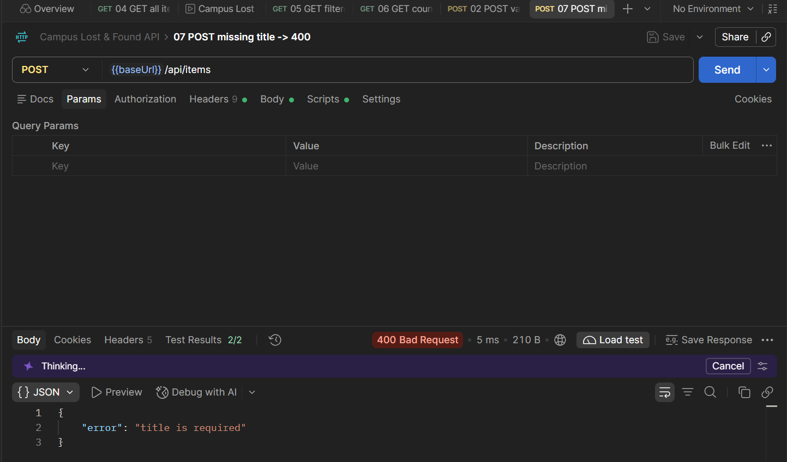
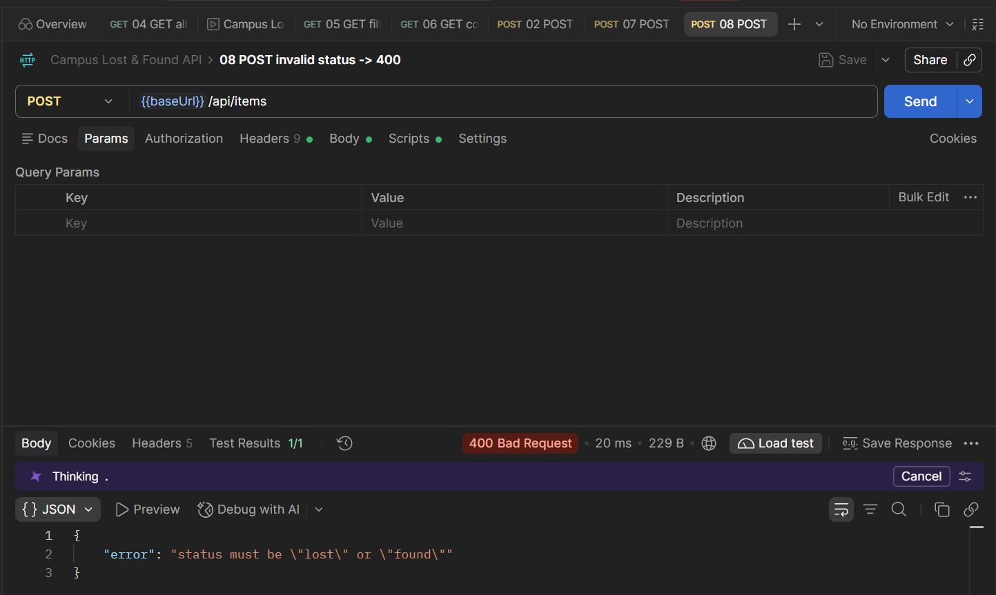
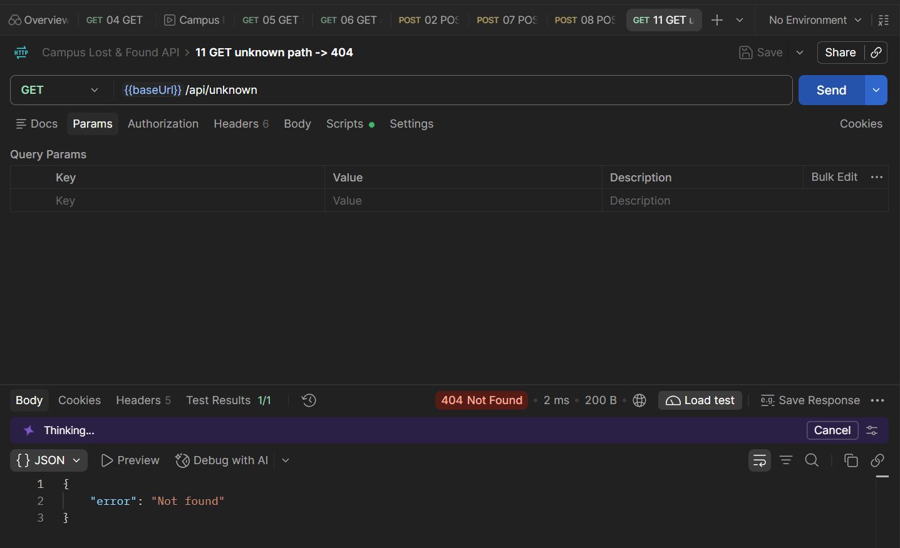

Task 4 — Event-Driven Design with EventEmitter (events, listeners):
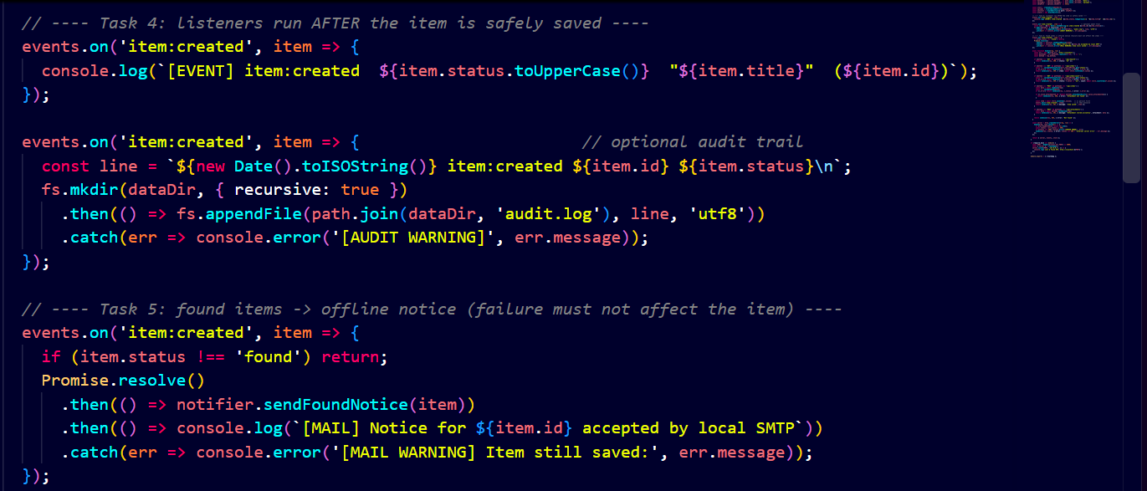
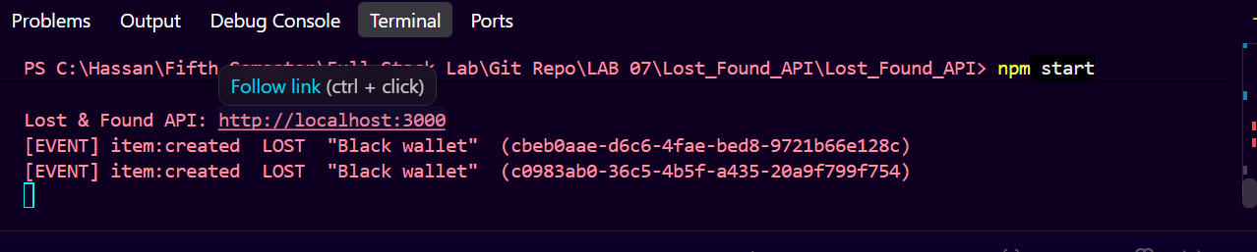

Task 5 — Offline Email Notice to a Local SMTP Receiver (Nodemailer, SMTP):
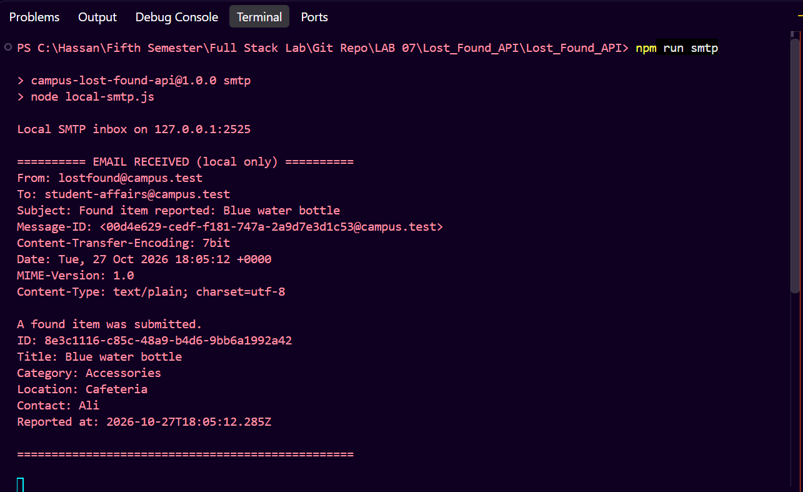

Task 6 — Private Evidence Upload with Formidable (multipart, file validation):
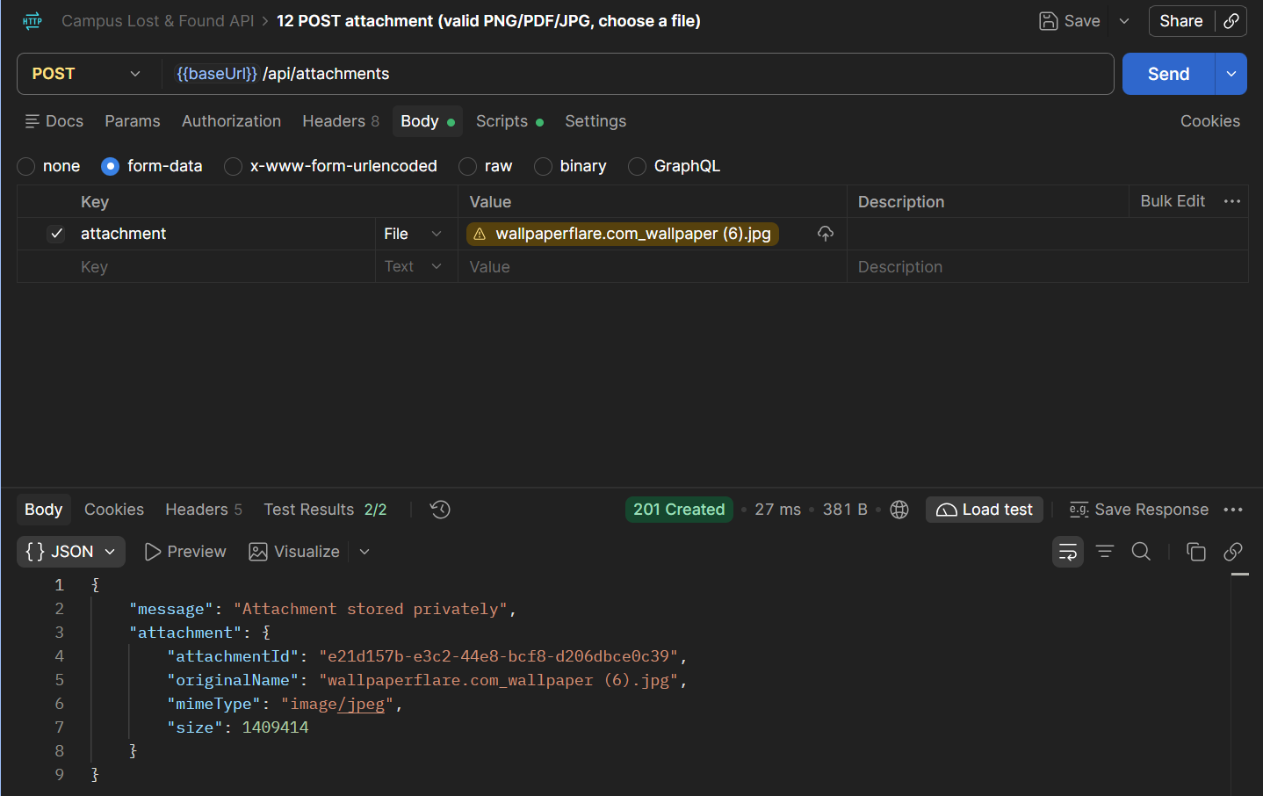
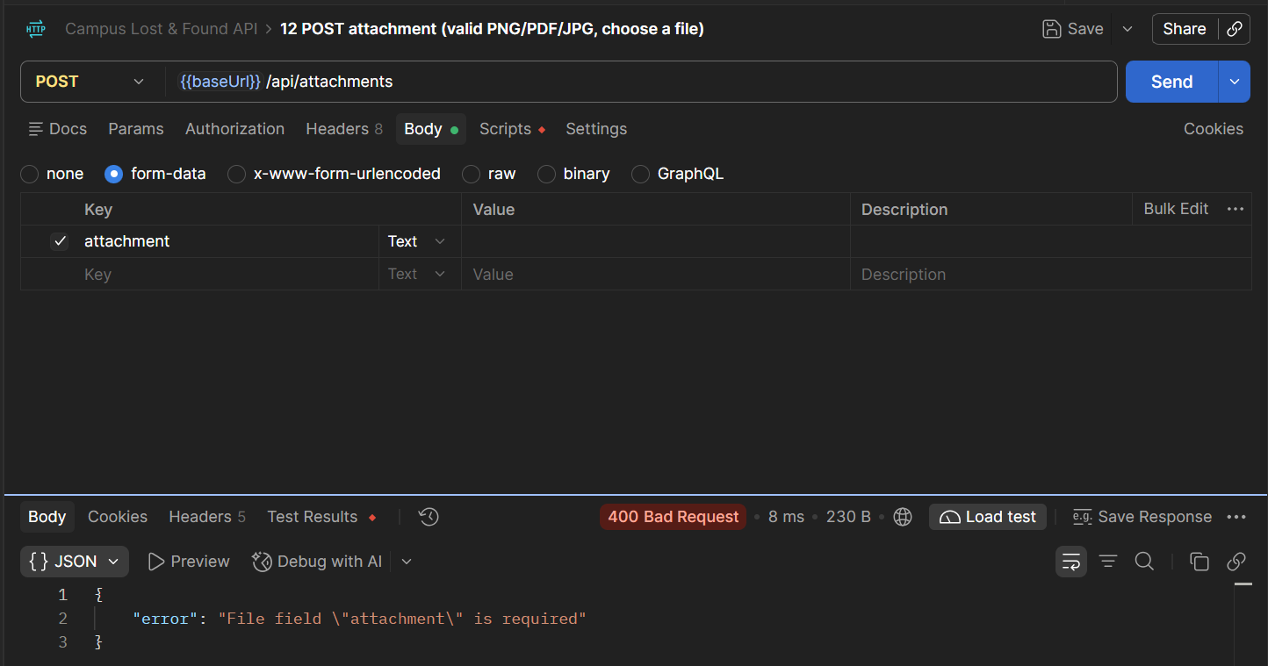

Task 7 — Postman Collection with Automated Tests (Postman, test scripts):
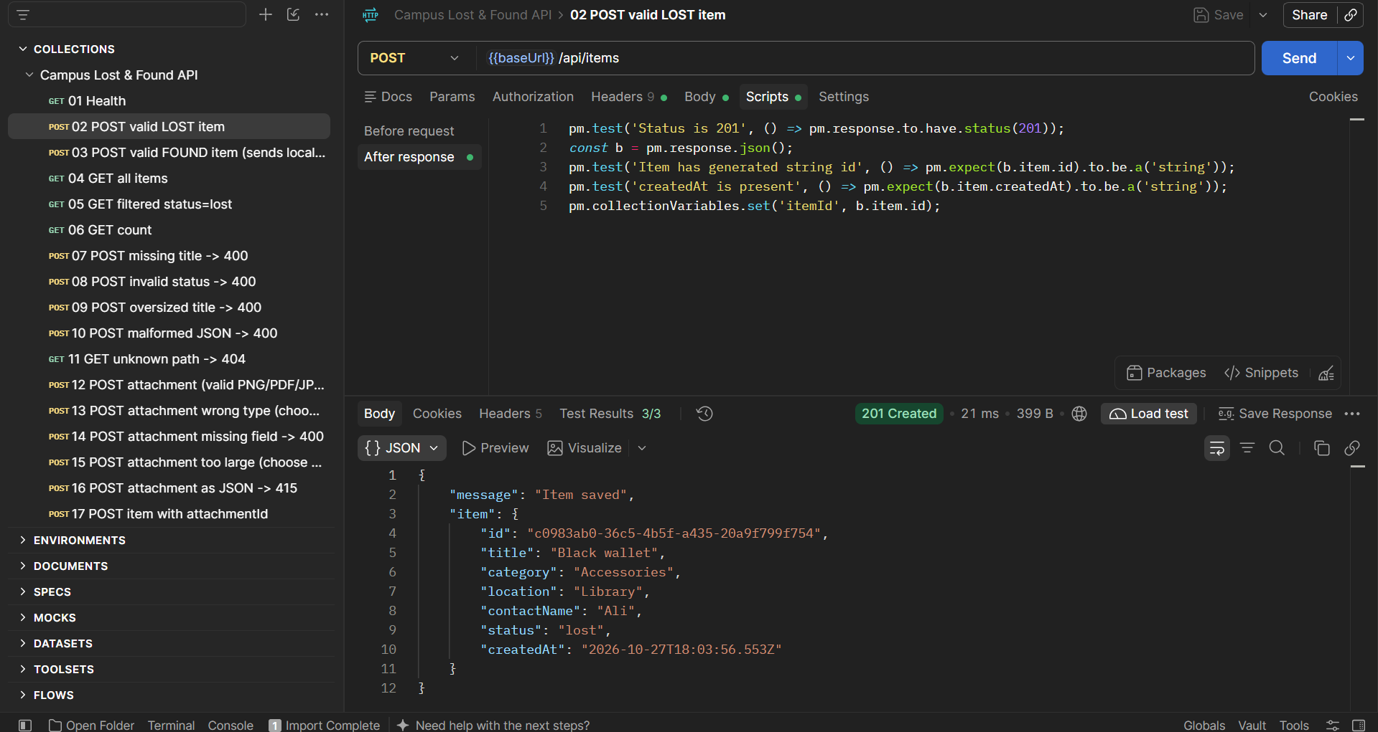
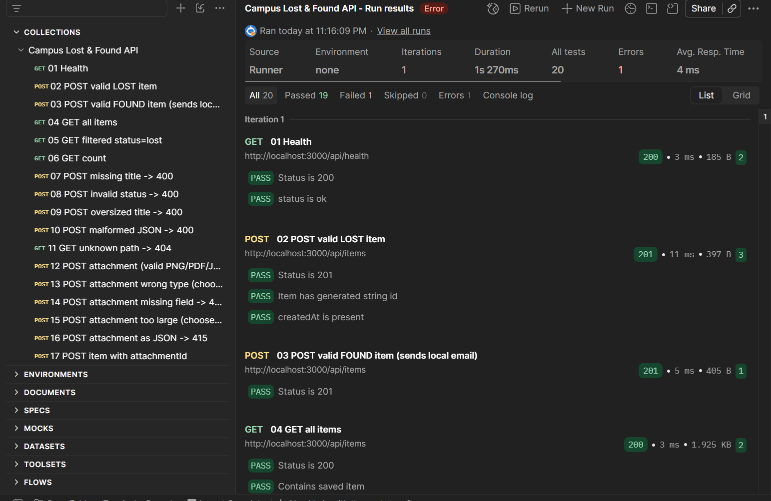

Task 8 — End-to-End Demonstration:
